Project Report: SAP-1 Microcomputer Design in Logisim

1. Introduction
The SAP-1 (Simple as Possible) microcomputer is a foundational model for understanding basic computer architecture. This project implements a SAP-1 design in Logisim, a digital logic circuit simulation tool. The microcomputer supports five operations: LDA (Load Accumulator), ADD, SUB, OUT (Output), and HLT (Halt), demonstrating the core functionalities of a basic von Neumann architecture.

2. System Overview
The SAP-1 microcomputer consists of the following key components:
- Program Counter (PC): Manages the sequencing of instructions by keeping track of the memory address being executed.
- Memory Address Register (MAR): Temporarily stores the address of the instruction to be fetched from RAM.
- Random Access Memory (RAM): Stores instructions and data for execution.
- Instruction Register (IR): Holds the current instruction fetched from memory.
- Controller/Sequencer: Generates control signals to coordinate the execution of instructions.
- Arithmetic Logic Unit (ALU): Performs arithmetic operations like addition and subtraction.
- Accumulator (ACC): Stores the result of ALU operations.
- B Register: Temporarily holds data to be used in arithmetic operations.
- Output Register: Displays results for the user.
- Clock: Synchronizes the operations across components.

3. Component Design
Each component of the SAP-1 is designed as an independent module in Logisim, interconnected via buses and control signals.
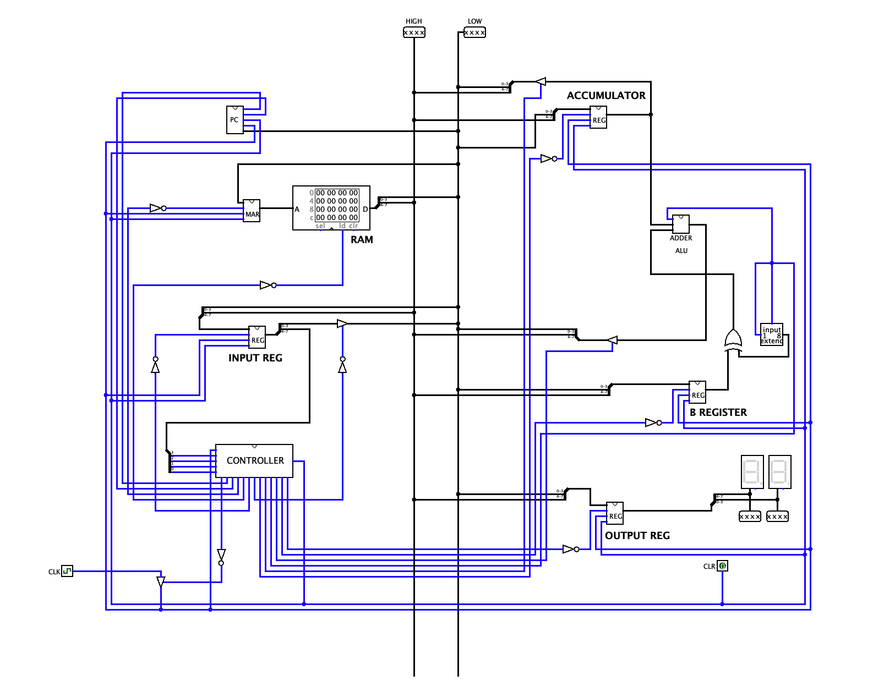
3.1 Program Counter (PC):
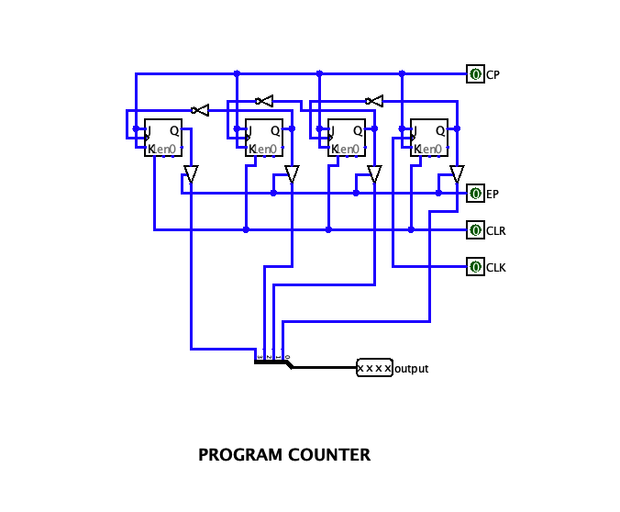
- The PC is a 4-bit counter that increments with each clock cycle, pointing to the next instruction in RAM.
- It includes an enable signal to load new addresses when branching.

3.2 Memory Address Register (MAR):
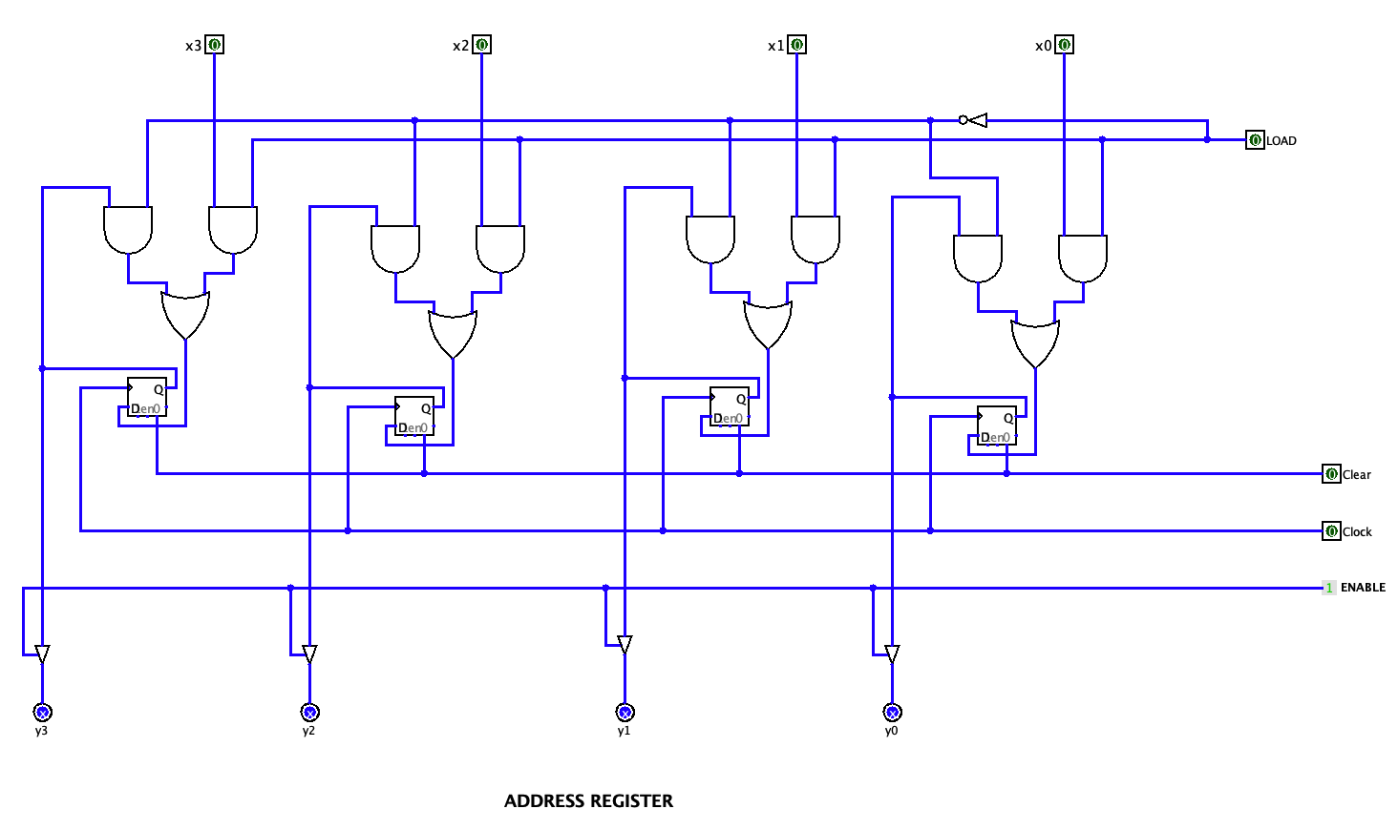
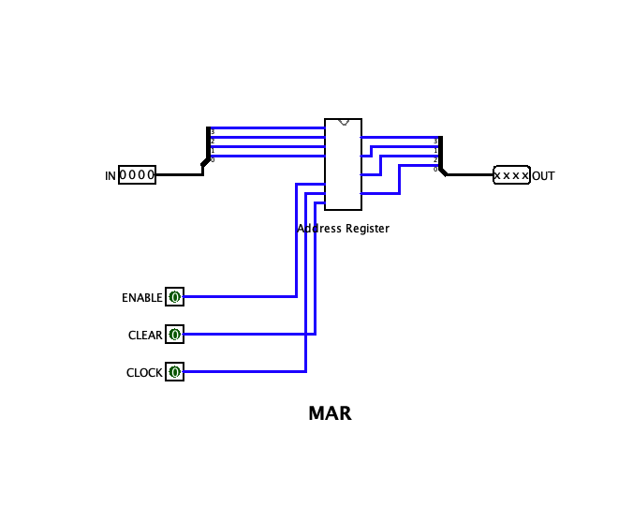
- The MAR holds the memory address fetched by the PC or externally loaded via the address bus.
- It connects directly to RAM for fetching instructions.

3.3 Random Access Memory (RAM):
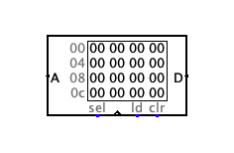
- A 4x8 RAM module stores up to 16 instructions, each represented as an 8-bit binary word.
- The first 4 bits represent the opcode, while the last 4 bits hold the operand.

3.4 Instruction Register (Input Register):
- This register decodes the opcode and sends it to the controller.
- It splits the instruction into opcode and operand for further processing.

3.5 ALU and Registers:
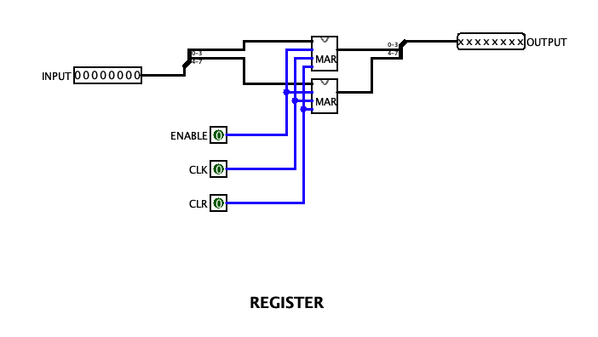
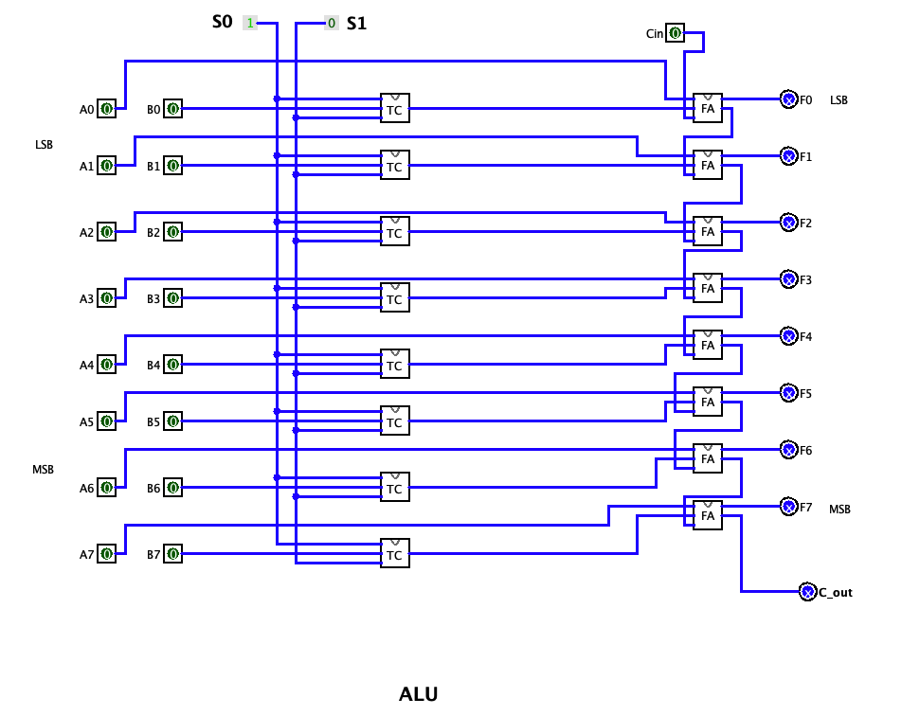
- The ALU supports basic operations: addition and subtraction.
- The accumulator (ACC) stores ALU results, while the B register provides operands.

3.6 Controller/Sequencer:
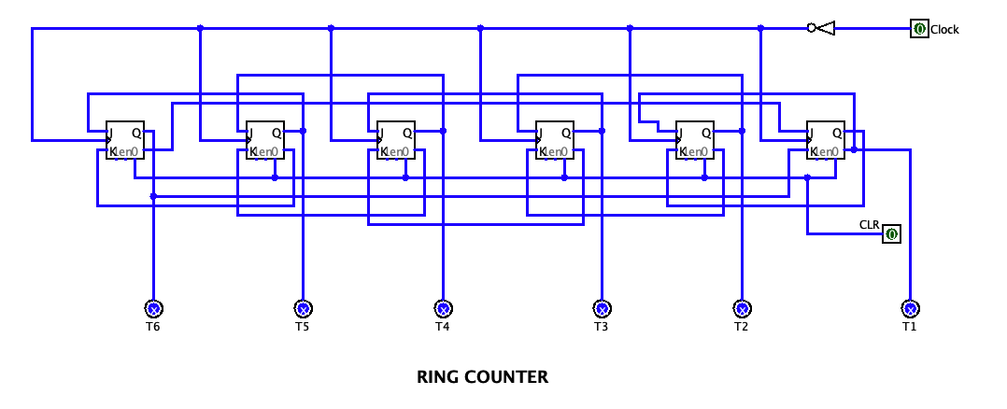
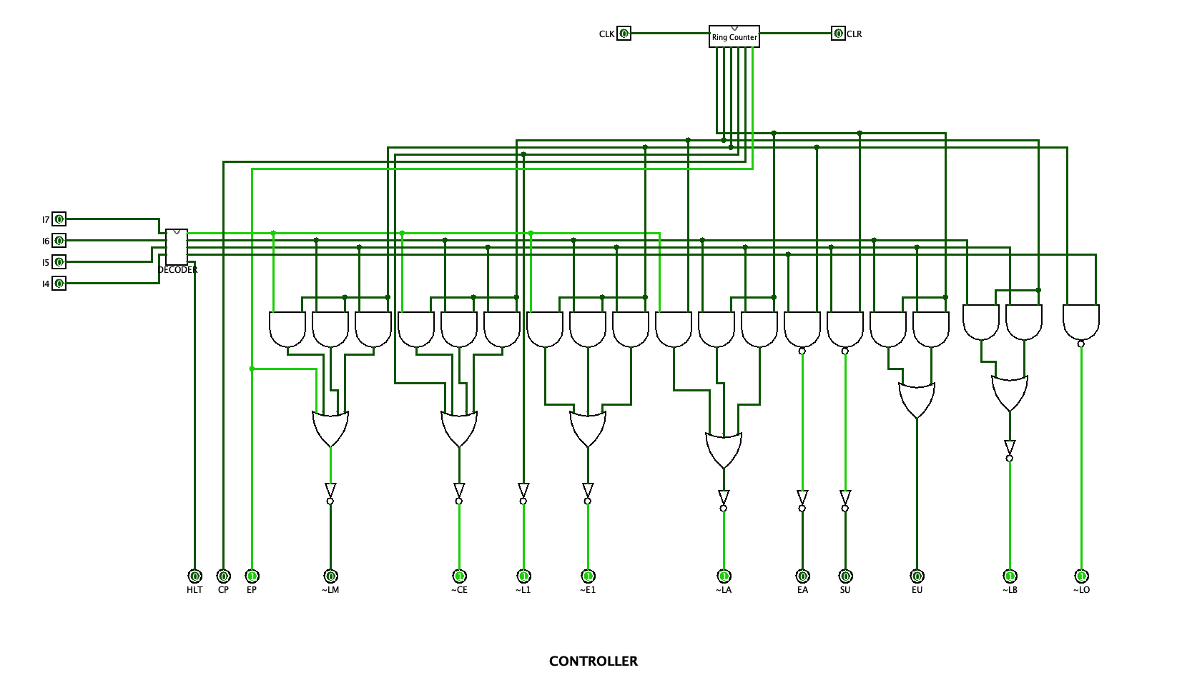
- Designed as a finite state machine, it generates control signals like `LOAD`, `ADD`, `SUB`, `HLT`, and `OUT`.
- Implements microinstructions for each operation using a hardwired approach.

3.7 Output Register:
- This register receives data from the accumulator and displays it on a 7-segment display.

4. Instruction Execution
The SAP-1 executes instructions in a sequence of fetch, decode, and execute cycles.

4.1 LDA (Load Accumulator):
- Loads data from a memory location into the accumulator.
- Control Signals: Enable MAR, Enable RAM, Load ACC.

4.2 ADD:
- Adds the contents of the B register to the accumulator.
- Control Signals: Load B, Perform ADD, Store in ACC.

4.3 SUB:
- Subtracts the contents of the B register from the accumulator.
- Control Signals: Load B, Perform SUB, Store in ACC.

4.4 OUT (Output):
- Transfers data from the accumulator to the output register.
- Control Signals: Load OUT.

4.5 HLT (Halt):
- Stops the clock, halting all operations.
- Control Signals: None (halts clock).

5. Operation Testing
The design was tested with a series of instructions loaded into RAM.
Example:

Address | Instruction | Opcode | Explanation | Expected Outcome
0x0 | LDA 0x3 | 0000 | Load the value at RAM address 0x3 into the accumulator (ACC). | ACC = RAM[0x3]
0x1 | ADD 0x4 | 0001 | Add the value at RAM address 0x4 to the accumulator (ACC). | ACC = ACC + RAM[0x4]
0x2 | SUB 0x5 | 0010 | Subtract the value at RAM address 0x5 from the accumulator (ACC). | ACC = ACC - RAM[0x5]
0x3 | OUT | 1110 | Send the value in the accumulator (ACC) to the output register. | Output Register = ACC
0x4 | HLT | 1111 | Halt the system, stopping all operations. | System halts, clock stops

Results were verified by observing the data flow across components and outputs on the 7-segment display.

6. Challenges and Solutions
Challenge: Synchronizing control signals for accurate execution.
Solution: A detailed state diagram ensured proper sequencing and signal generation.

Challenge: Designing the ALU for multiple operations.
Solution: Multiplexers were used to select between addition and subtraction based on control signals.

7. Conclusion
The SAP-1 microcomputer was successfully implemented in Logisim, demonstrating its ability to perform fundamental operations in a simulated environment. This project serves as a stepping stone to understanding complex architectures and microprocessor designs.

